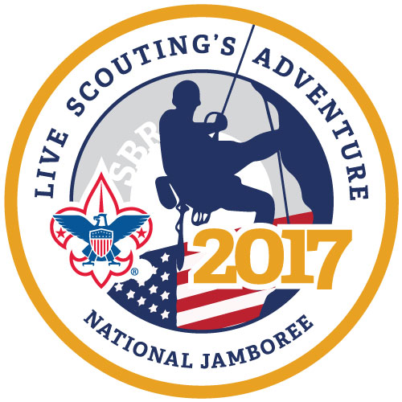  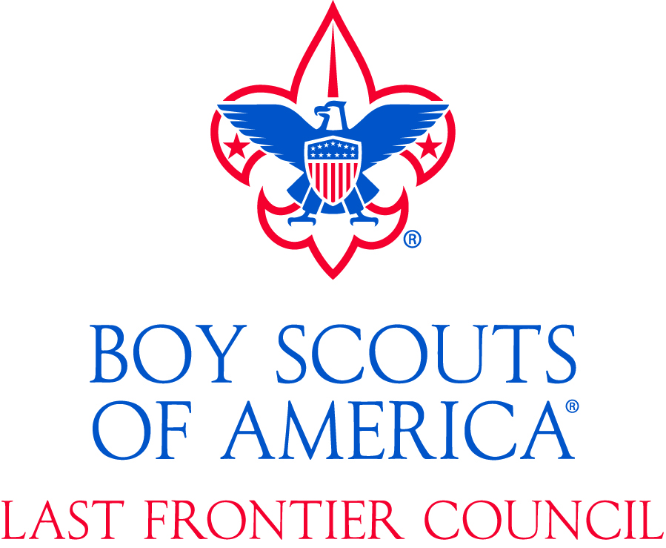 |  |  | 2017 National Scout Jamboree  Join us for Scouting’s Premiere once every four your event at the Summit  Connect with us  Jamboree Blog:  lfcjambo.org  Facebook:  Last Frontier Council:2017 National Scout Jamboree  National Jamboree Website:  summitbsa.org/events/jamboree  #lfcjambo #lfcbsa #scouting |  |  | Announcing the 2017 National Scout Jamboree  July 19th – 28th  Live Scouting’s Adventure

Are you ready to Live Scouting’s Adventure?  Come join over 200 Scouts from the Last Frontier Council and 40,000 Scouts from around the world for the 2017 National Scout Jamboree at the Summit Bechtel Reserve in West Virginia  What is Jamboree?  This exciting event occurs once every four years and brings together Scouts from all over the United States and the world with exciting events and activity. It is Scouting greatest party  Attend Jamboree and see all that Scouting has to offer including zip lines, water sports, arena shows, shooting sports, STEM activities and more |  |  | When is it?  The 2017 event is scheduled for July 19th to July 28th. These dates do not include the expected travel time needed from Oklahoma to the Summit  “Attending Jamboree at the Summit is an experience not to be missed”  How much is it going to cost?  Final pricing is estimated at less than $1,999 and will include all transportation, meals, event activities and gear  Who can go?  Scouts must be at least 12 years of age by the first day of Jamboree and First Class Rank.  More specific requirements can be found on the Jamboree registration site  What about the Leaders?  Troop and Crew Adult leadership have been chosen from a pool of experienced Scouters by the Jamboree Committee. Look for leaders to be recruiting in your area. |  |  | Climbing is a favorite activity  Where to I sign up?  Visit lfcjambo.org for signup information  Sign up:  http://www.summitbsa.org/events/jamboree/jamboree-registration/  Why sign up now?  Jamboree is a very popular event usually resulting in a waiting list. Early registration will ensure you the best chance for a slot from your area Jamboree Troop  Live Scouting’s Adventure! Join us and 40,000 of your closest friends for the 2017 National Scout Jamboree!

